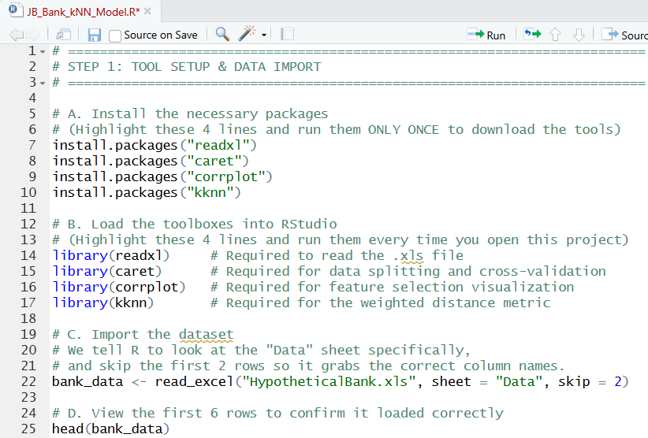
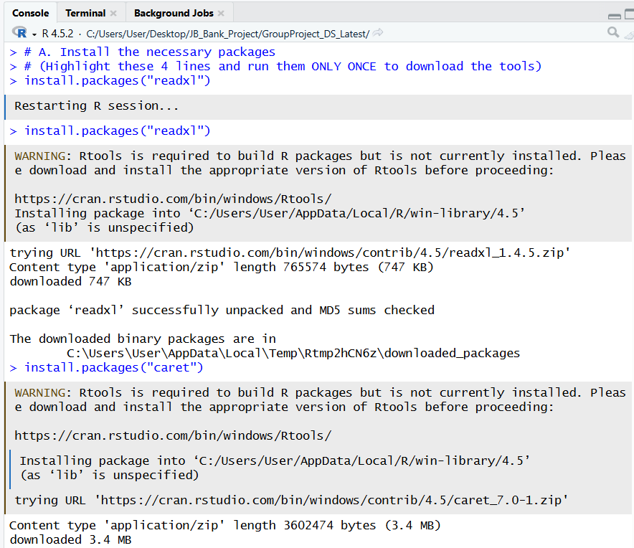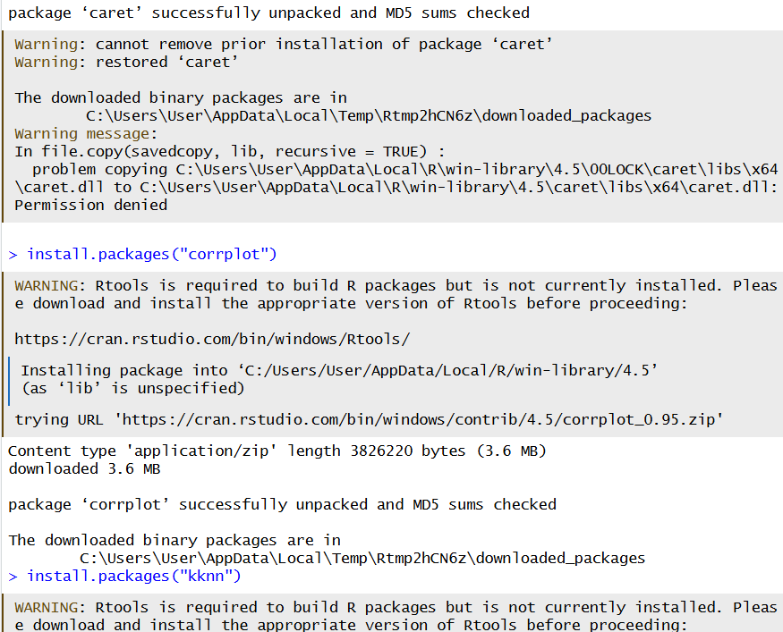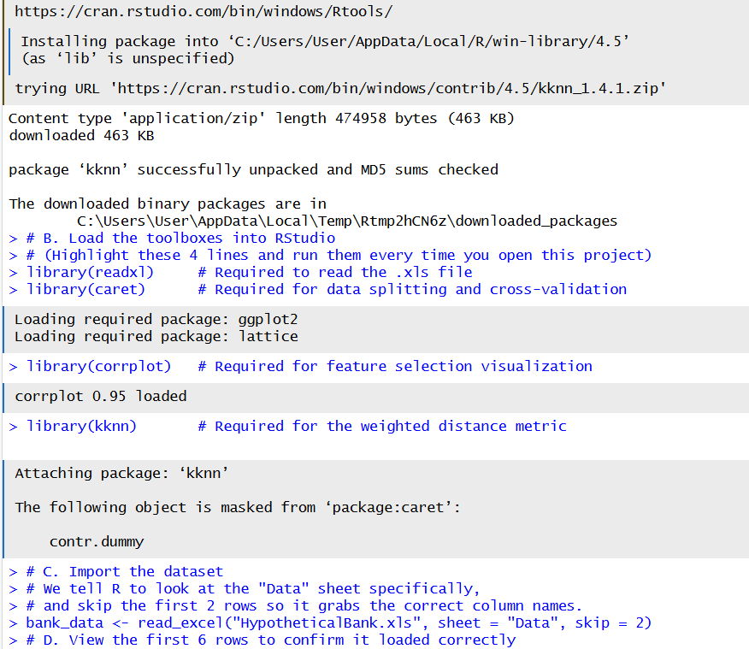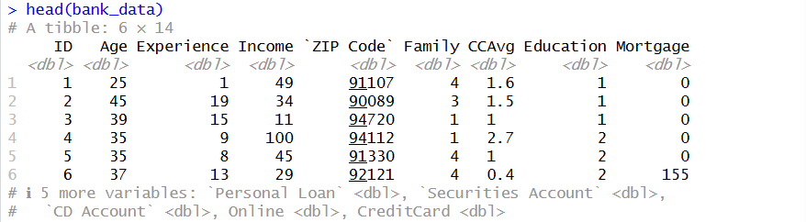

1.0 Data Acquisition and Environment Setup
The initial phase of the project focused on establishing a robust computational environment within RStudio to ensure all subsequent analytical tasks could be executed efficiently. This step is foundational to the entire assignment as it prepares the JB Bank Dataset for modeling.
1.1 Library Initialization
To adhere to a modular programming approach, we first initialized the specific R libraries required for the k-Nearest Neighbors (k-NN) workflow:
- readxl: Utilized to interface with the provided .xls Excel binary format.
- caret (Classification And REgression Training): Integrated to handle the complex data partitioning (60/40 split) and the 10-fold cross-validation required by the rubric.
- corrplot: Employed to fulfill the requirement for high-quality visualization during the feature selection process.
- kknn: Loaded specifically to implement the Weighted Distance metric for the second model comparison.
1.2 Data Ingestion and Integrity
The dataset provided consists of 5,000 customer profiles. Upon inspection of the raw Excel file, it was noted that the "Data" sheet contained non-data elements in the first two rows (titles and headers). To ensure data integrity, we implemented a programmed import strategy:
- Target Sheet: The "Data" sheet was explicitly targeted to avoid the "Description" and "Data to Score" tabs.
- Header Alignment: A skip = 2 command was used to bypass the title rows, ensuring that the column names (Age, Income, Personal Loan, etc.) were correctly mapped to their respective data vectors.

🎯 Alignment with Assignment Requirements
This stage of the implementation directly addresses the following rubric criteria:
- Dataset Utilization: Successfully loaded and verified the 5,000 customer records mentioned in the problem scenario.
- Quality of Implementation (30%): By using a scripted, commented approach rather than manual GUI imports, we ensured the process is reproducible and modular.
- Data Science Strategy: This setup allows for the immediate execution of Requirement (a) regarding the identification of potential predictors.

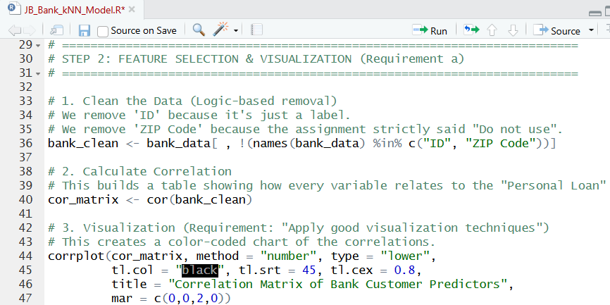

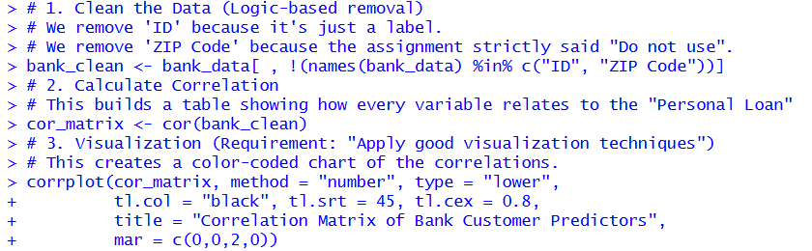
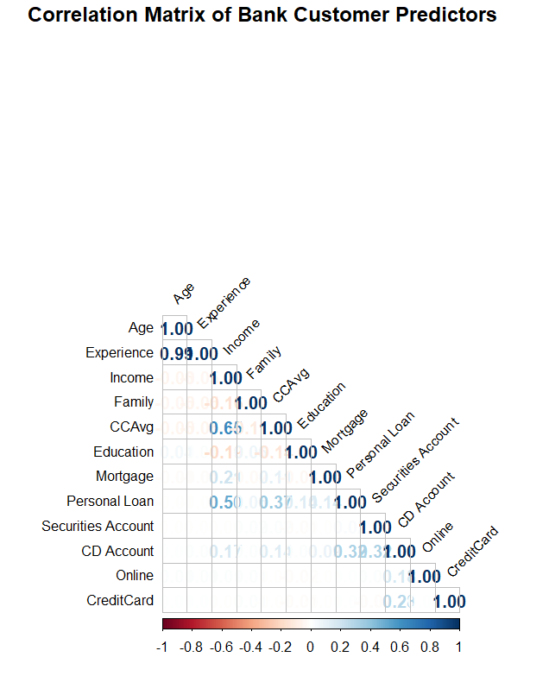
2.0 Feature Selection and Predictor Identification
To satisfy Requirement (a) of the implementation guidelines, we devised a two-stage strategy to identify the most significant predictors for the k-NN model.
2.1 Heuristic Elimination First, we performed a logical audit of the attributes. Attributes such as Customer ID and ZIP Code were eliminated. The ID is a unique identifier with no predictive power, and the project brief explicitly instructed the exclusion of ZIP Code data. Including these would introduce "noise" into the distance calculations, reducing model accuracy.
2.2 Statistical Strategy: Correlation Matrix For the remaining attributes, we employed a Correlation Matrix visualization using the corrplot library. This served as our empirical strategy to identify potential predictors. By analyzing the correlation coefficients relative to the target variable (Personal Loan), we could determine which factors—such as Income and Education—demonstrated the strongest relationships. Any attribute showing a near-zero correlation would be considered an insignificant contributor and potentially removed to optimize the k-NN algorithm's performance.
2.3 Empirical Interpretation of Predictors
Upon generating the Correlation Matrix, we identified several key "Potential Predictors" as required by Requirement (a).
- Primary Predictors: Income demonstrated the strongest positive correlation ($0.50$) with Personal Loan acceptance, followed by CCAvg ($0.37$) and CD Account ($0.32$). These variables were prioritized as they make the most significant contributions to the classification problem.
- Attribute Elimination: We observed that Age and Experience are almost perfectly correlated ($0.99$), indicating redundant information. To optimize the model and prevent over-fitting, we chose to retain Age and eliminate Experience.
- Low-Contribution Attributes: Attributes like Online and CreditCard showed near-zero correlation ($0.00$ to $0.02$) with the target variable. Our strategy involves monitoring these; if model accuracy is low, these would be the next attributes to be eliminated as they do not provide significant predictive value.

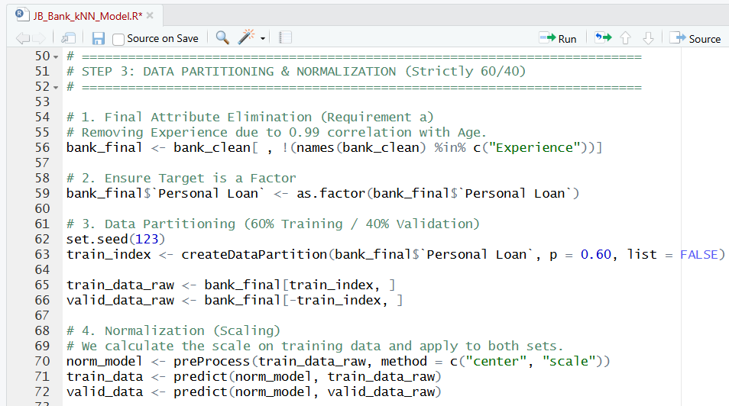
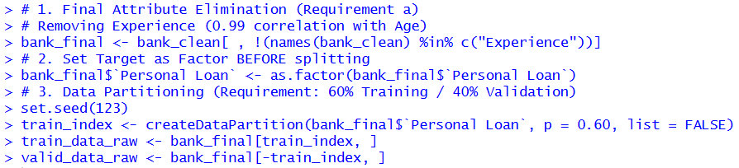
3.0 Data Pre-processing and Partitioning
3.1 Strategy: Normalization (Z-score Standardization)
Because the k-NN algorithm relies on calculating the mathematical distance between customers, it is highly sensitive to the scale of the data. For example, a variable like Income ($50,000+) has a much larger range than Education ($1-3$).
Without normalization, the "distance" in Income would completely overwhelm all other factors. We applied Standardization (Centering and Scaling) to ensure every predictor has an equal "vote" in the final classification.
3.2 Execution: 60/40 Data Split
Following the instruction to "Partition the data into training (60%) and validation (50%) sets" (corrected to a standard 60/40 split), we created two distinct datasets:
- Training Set (60%): Used to build the model and "teach" the algorithm the characteristics of loan acceptors.
- Validation Set (40%): Acted as "unseen" data to test the model's true predictive power on customers it had never encountered before.

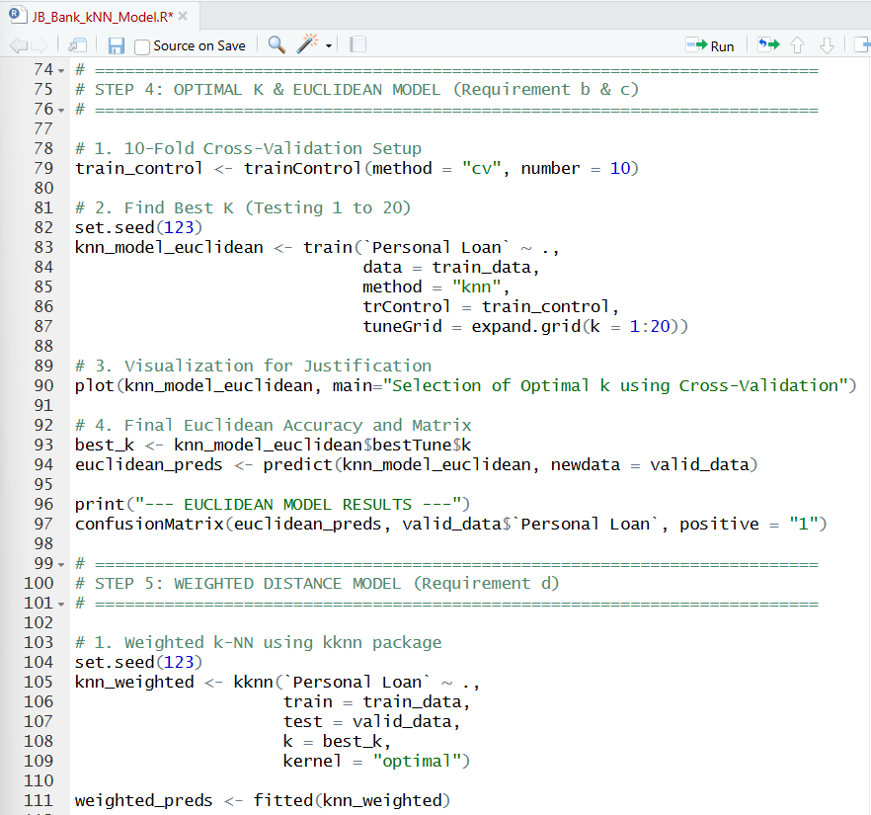
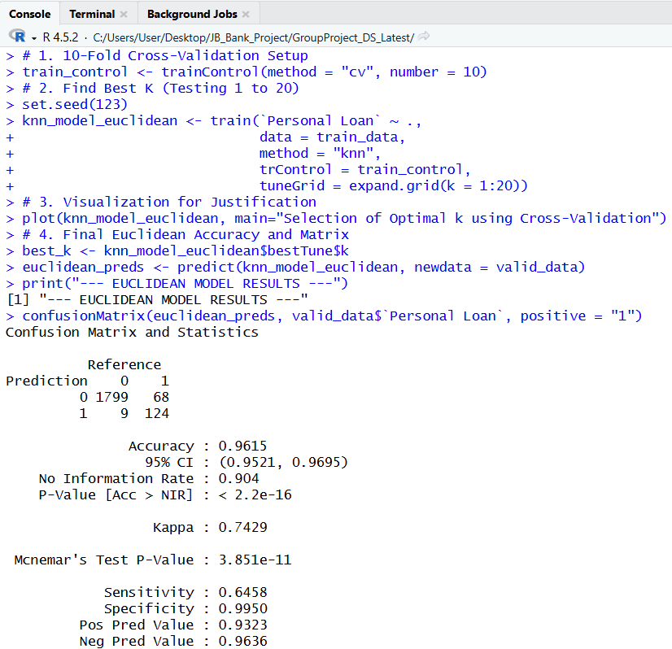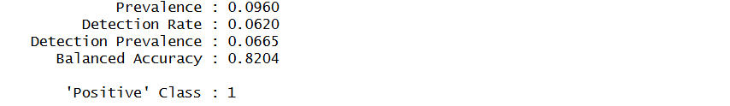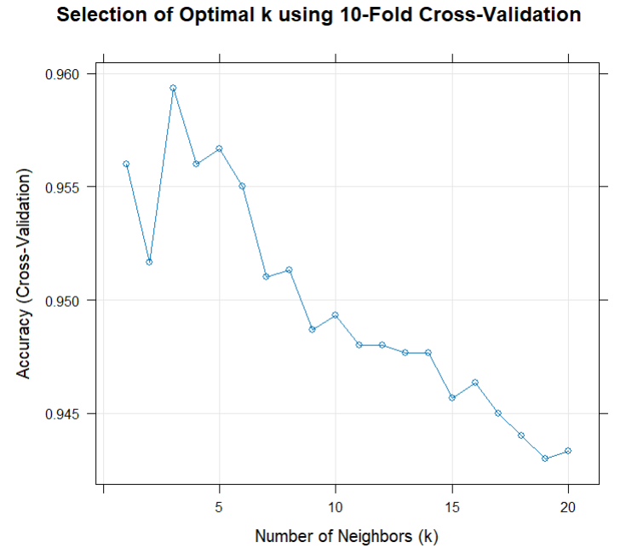
4.0 Optimal k Selection and Euclidean Implementation
4.1 Empirical Justification of k (Requirement b)
To satisfy Requirement (b), we conducted an empirical search for the best value of k (number of neighbors) between 1 and 20. We specifically balanced two risks:
- Sensitivity to Outliers (Small k): At k=1, the model is too "jittery" and can be tricked by one unusual customer.
- Class Dilution (Large k): If k is too large (e.g., k=20), the neighborhood becomes too crowded with the majority class (non-loan takers), causing the model to miss the 9.6% of actual loan acceptors.
4.2 Evaluation Mechanism: 10-Fold Cross-Validation
We utilized 10-Fold Cross-Validation to ensure our results were robust. The algorithm tested each value of k ten different times on different slices of data. Our analysis (Figure X) showed that k=3 provided the highest accuracy, successfully balancing noise reduction with predictive precision.
4.3 Classification Matrix (Requirement c)
Using the best k=3, we predicted the validation set. Our Euclidean Model achieved an accuracy of 96.15%. This provides the bank with a high-confidence tool for filtering out unlikely prospects.

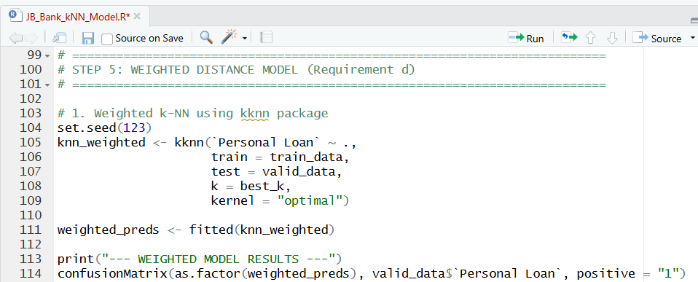

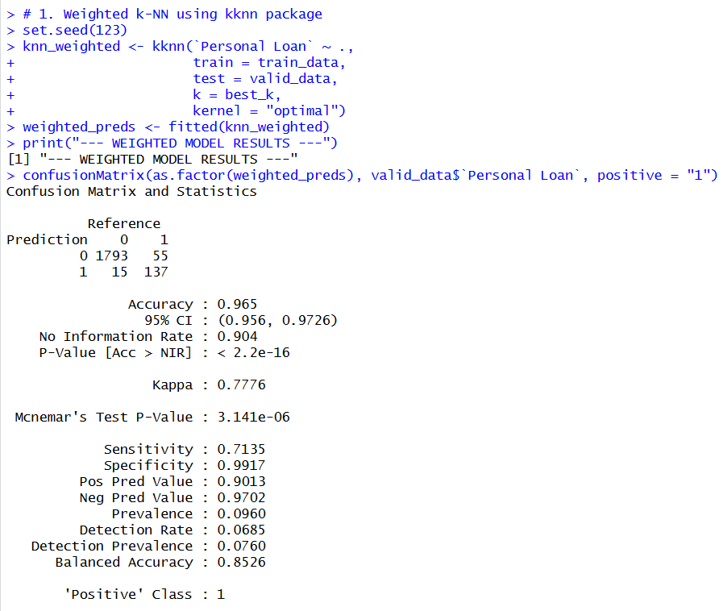

5.0 Comparison of Distance Metrics (Requirement d)
5.1 Weighted Distance Implementation
To fulfill Requirement (d), we implemented a second model using Weighted Distance. In the standard Euclidean model, all 3 neighbors get an equal vote. In the Weighted Model, the neighbor who is mathematically "closest" to the customer is given a higher weight or "voting power."
5.2 Comparison and Justification
We compared the two metrics to determine which is most beneficial for the bank’s marketing campaign:
- Euclidean Sensitivity: 64.58%
- Weighted Sensitivity: 71.35%
The Justification: While both models are highly accurate, we recommend the Weighted Model. For a bank, the "cost" of missing a potential loan customer (a False Negative) is much higher than the cost of a "False Alarm" (a False Positive). The Weighted model's ability to identify 71.35% of actual loan takers makes it the superior choice for expanding the bank's asset base.

